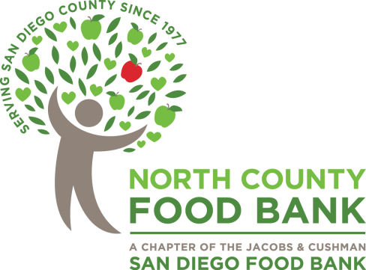

North County Food Bank
Drive Out Hunger Golf Classic
July 22, 2019

In-Kind / Auction Donation Form

Contact Name: _______________________________________________________

Business Name: ______________________________________________________

Item Description: _____________________________________________________
____________________________________________________________________
____________________________________________________________________
Expiration Date: ______________________________________________________

Market Value: ________________________________________________________

Business Address: ____________________________________________________

_____________________________________________________________________

Address (For thanking letter, if different than above): ___________________________
_____________________________________________________________________

Phone #: _____________________________________________________________

Email: ______________________________________________________________________

Thank you for supporting the North County Food Bank. If you request it, a donation receipt/tax-deductibility statement for the fair market value of your donation to this event will be sent to the address you provide.

Mail or fax form to:
Chad Deal/San Diego Food Bank
9850 Distribution Avenue, San Diego, CA 92121
Fax: 858-527-1457
Phone: 858-863-5199
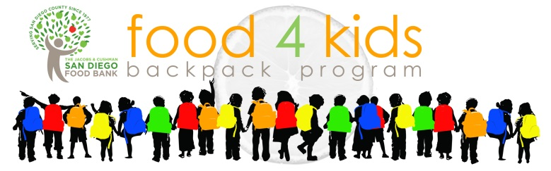
CDeal@sandiegofoodbank.org
The San Diego Food Bank is a 501(c)(3) organization. Our tax ID number is 20-4374795.
Contributions are tax deductible to the extent allowed by law. Please retain a copy of this form as a receipt for tax purposes.

